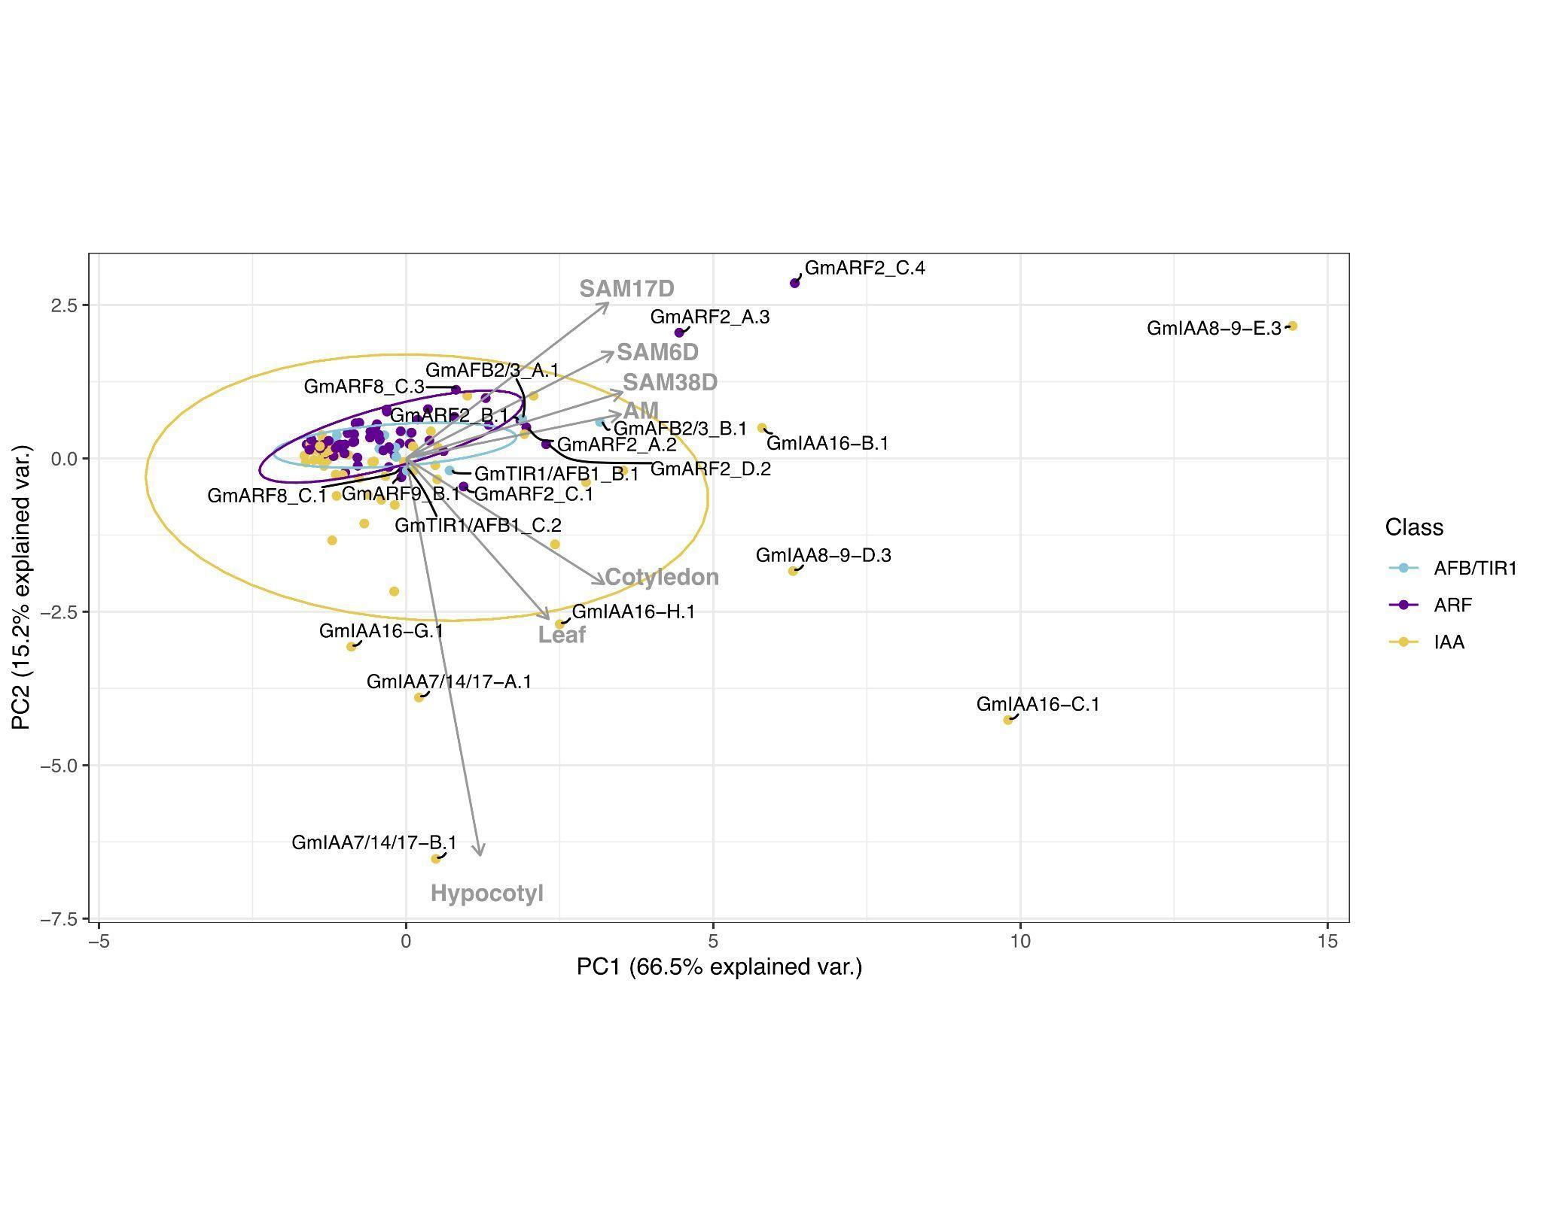

Figure 1. Correlation-based Principal Component Analysis (PCA): biplot of gene transcript expression and explanatory tissues involved in plant aerial architecture as eigenvectors (grey arrows), n = 7). Principal components 1 and 2 account for 81.7% of the total inertia. Ellipses are used here as a visual representation of dispersion of data points within each group (TIR1/AFB, ARF, and Aux/IAA (IAA)) with a 70% confidence interval. TIR1/AFB genes are colored cyan, ARF genes are colored purple, and Aux/IAA (IAA) genes are colored yellow. Some labels are connected to their respective points with hard lines. Genes clustering together inside the ellipses are hypothesized to have more pleiotropic effects on plant growth and development, whereas genes associated with a specific RCC tissue (genes that fall along an eigenvector, outside of the respectively colored ellipse) are hypothesized to have narrower effects and be more amenable to engineering RCC traits through gene editing.

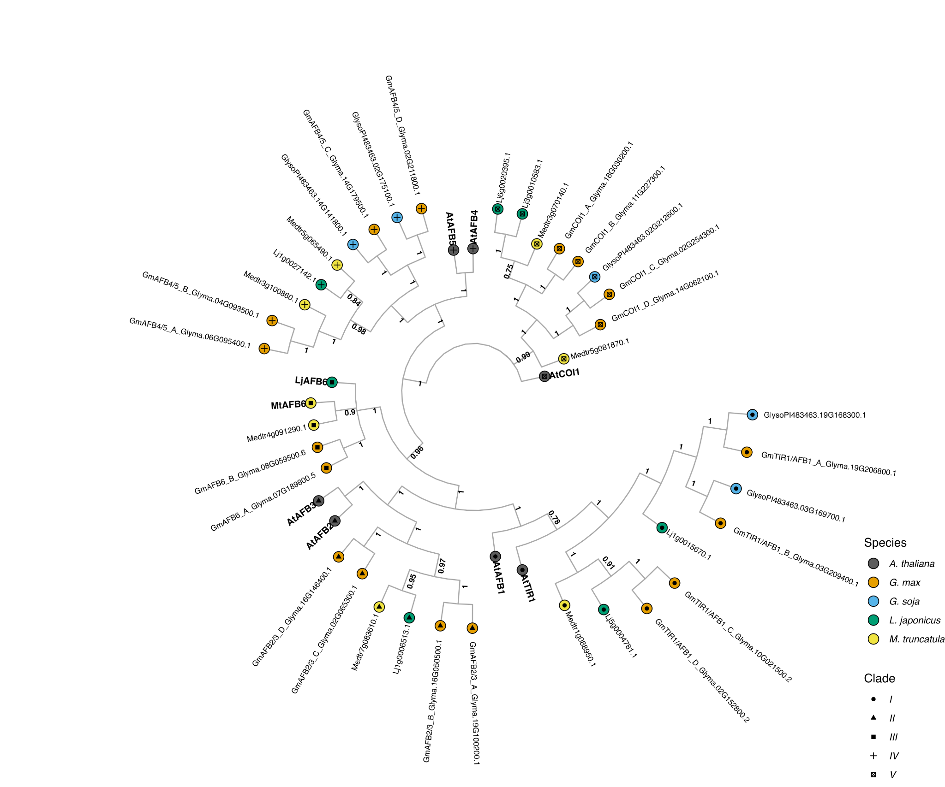

Figure 2.The evolutionary relationships between *G. max* TIR1/AFB proteins, and *A. thaliana* and other legume species orthologs. The historical relationship was inferred using the Bayesian Inference method (Ronquist *et al*., 2012). The optimal tree is drawn according to the posterior probability of the evolutionary distances. The posterior probability of each node is labeled. Each tip is colored according to species, with *A. thaliana* in black, *G. max* in orange, *G. soja* in light blue, *L. japonicus* in green, and *M. truncatula* in yellow. *A. thaliana* gene symbols are displayed in bold to better visualize clade separation. Clades are also defined by the shapes towards tip extremities, with clade I as a circle, clade II as a triangle, clade III as a square, clade IV as an addition sign, and clade V as a ballot box with an x. *G. max* geneswere named according to their orthology to *A. thaliana* followed by their gene ID.

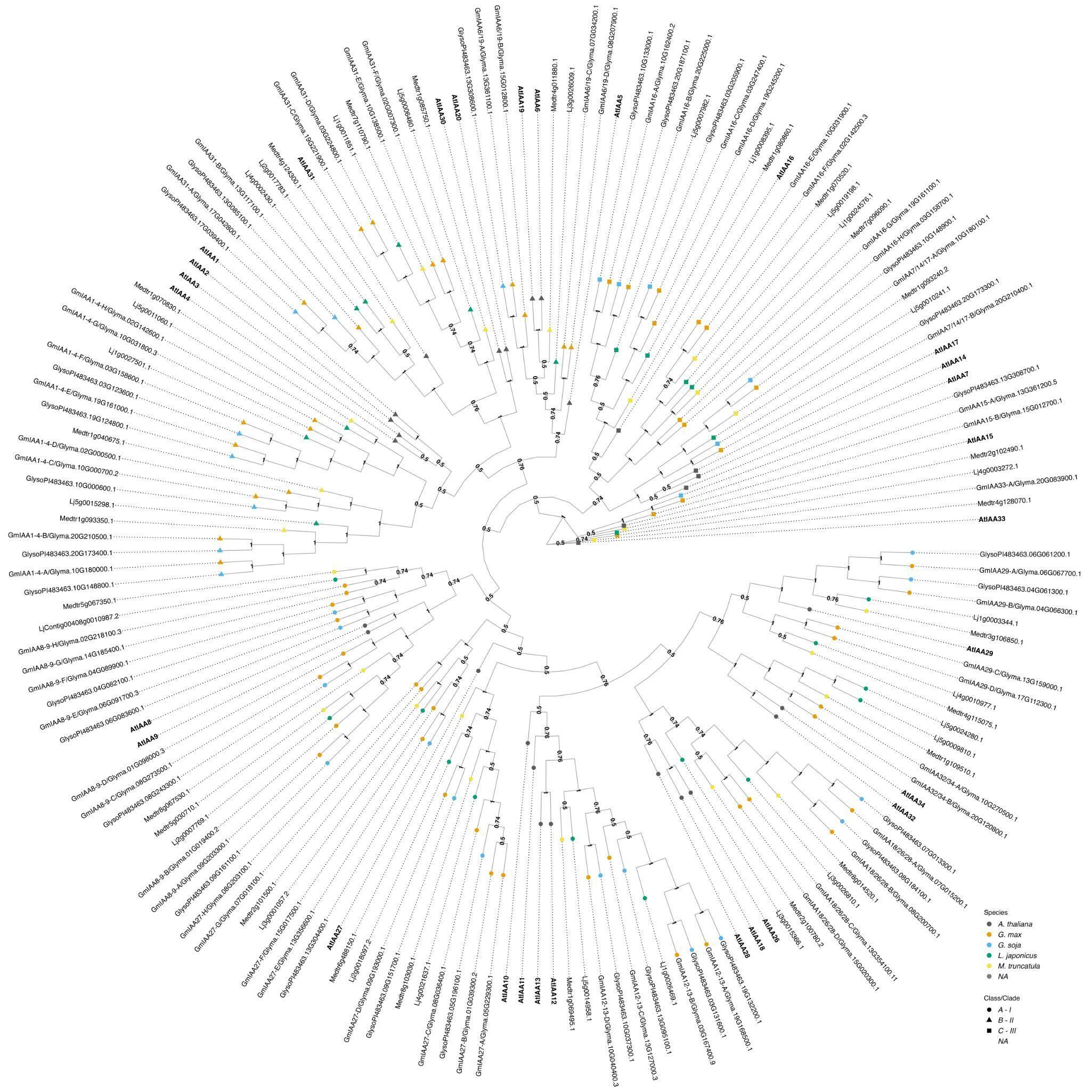

Figure 3. The evolutionary relationships between *G. max* Aux/IAA proteins, *A. thaliana* and other legume species orthologs. The historical relationship was inferred using the Bayesian Inference method (Ronquist *et al*., 2012). The optimal tree is drawn according to the posterior probability of the evolutionary distances. The posterior probability of each node is labeled. Each tip is colored according to species, with *A. thaliana* in black, *G. max* in orange, *G. soja* in light blue, *L. japonicus* in green, and *M. truncatula* in yellow. *A. thaliana* gene symbols are displayed in bold to better visualize assigned orthology. Aux/IAAs co-receptors are divided here into three classes/clades: Class A - I, represented as a circle; Class B - II, represented as a triangle, and class C - III, represented as a square. *G. max* were named according to both their orthology to *A. thaliana* followed by its gene ID. Nodes are labeled with their supporting probabilities in the center.

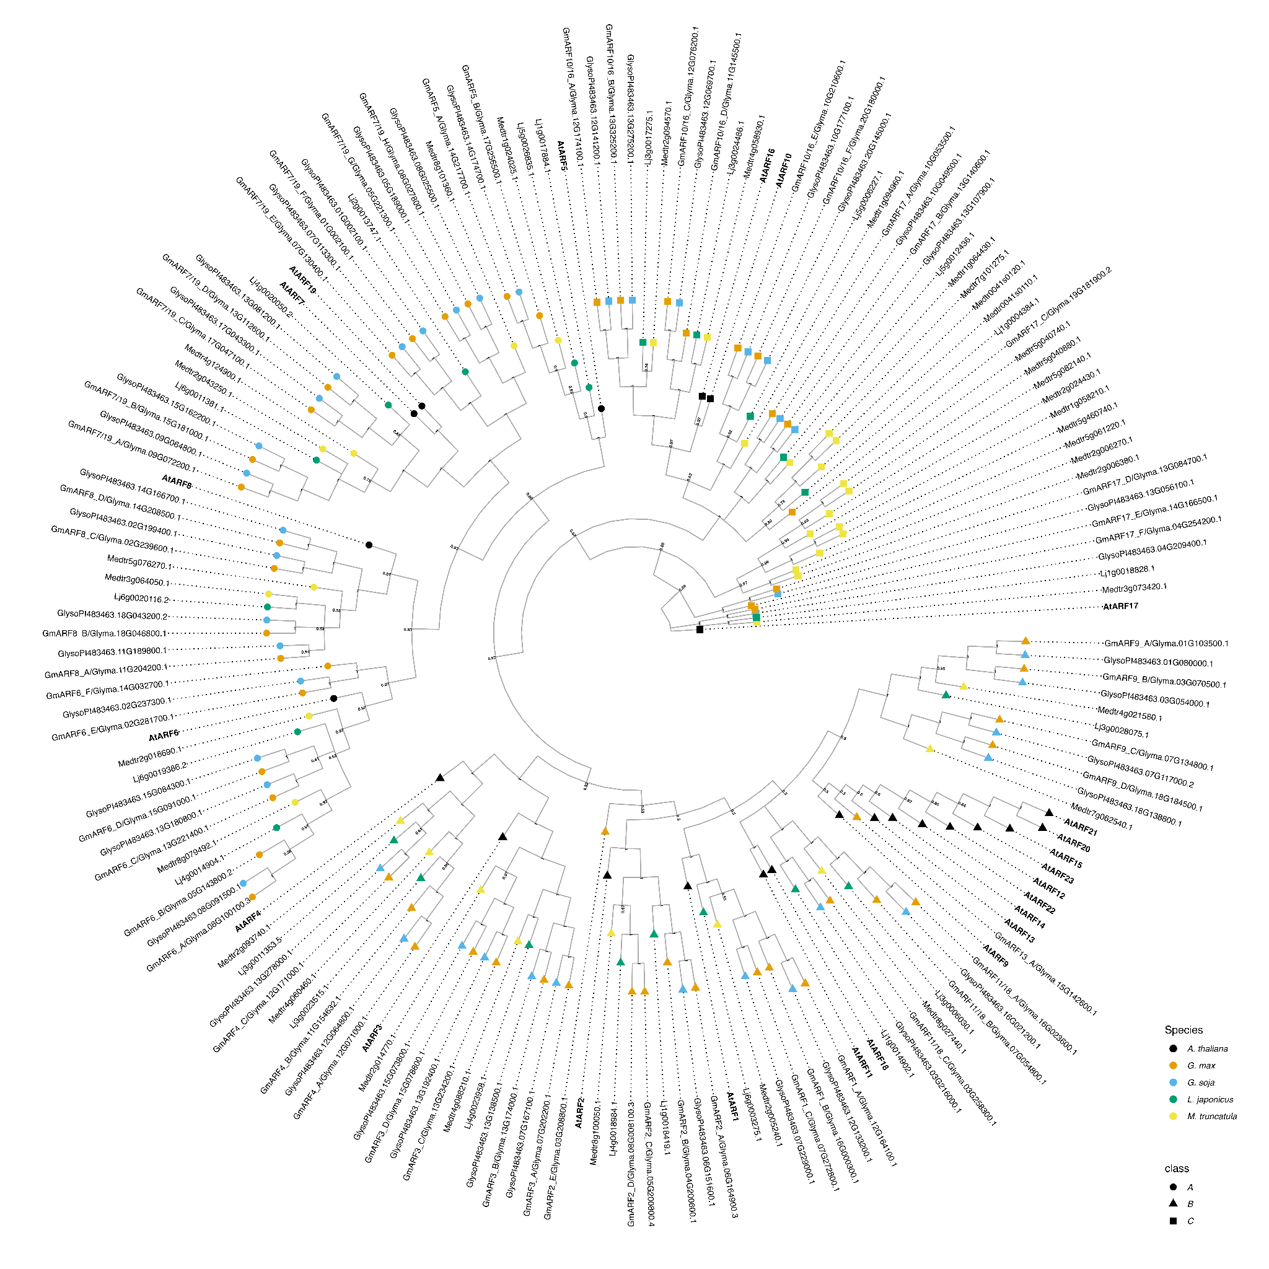

Figure4*.* The evolutionary relationships between *G. max* ARFs proteins, *A. thaliana* and other legume species orthologs. The historical relationship was inferred using Bayesian Inference (Ronquist *et al*., 2012). The optimal tree is drawn according to the posterior probability of the evolutionary distances. The posterior probability of each node is labeled. Each tip is colored according to species, with *A. thaliana* in dark grey, *G. max* in orange, *G. soja* in light blue, *L. japonicus* in green, and *M. truncatula* in yellow. *A. thaliana* gene symbols are displayed in bold to better visualize assigned orthology. ARFs are divided here into three classes/clades (Ulmasov *et al*., 1999; Finet *et al*., 2013): Class A - II, represented as a circle; Class B - I, represented as a triangle, and class C - III, represented as a square. *G. max* were named according to both their orthology to *A. thaliana* followed by its gene ID.